CHAROTAR UNIVERSITY OF SCIENCE & TECHNOLOGY DEVANG PATEL INSTITUTE OF ADVANCE TECHNOLOGY & RESEARCH
Department of Information Technology

Subject Name: Web Development Framework
Semester: III
Subject Code: ITUE203
Academic year: 2025-26 [ODD]

Practical File

No. | Aim of the Practical
8. | To connect the Finova portal with MySQL for storing user trades and retrieving portfolio data dynamically from the database.  Trade.php  PROGRAM CODE:  <?php  require '../php/session_manage.php';  require '../db/db.php';  if (!isLoggedIn() || $_SESSION['role'] !== 'user') {  header("Location: ../login.php");  exit;  }  if ($_SERVER['REQUEST_METHOD'] === 'POST' && isset($_POST['cancel_trade_id'])) {  $trade_id = intval($_POST['cancel_trade_id']);  $stmt = $conn->prepare("UPDATE trades SET status='cancelled' WHERE id=? AND user_id=? AND status='pending'");  $stmt->bind_param("ii", $trade_id, $_SESSION['user_id']);  $stmt->execute();  if ($stmt->affected_rows > 0) {  $success = "Trade #$trade_id cancelled successfully.";  } else {  $error = "Trade could not be cancelled.";  }  }  if ($_SERVER['REQUEST_METHOD'] === 'POST' && isset($_POST['coin'])) {  $coin_id = intval($_POST['coin']);  $usd = floatval($_POST['amount']);  $payment = $_POST['payment_method'];  $stmt = $conn->prepare("SELECT current_price FROM coins WHERE id=?");  $stmt->bind_param("i", $coin_id);  $stmt->execute();  $coinData = $stmt->get_result()->fetch_assoc();  if ($coinData && $usd > 0) {  $coinPrice = $coinData['current_price'];  $quantity = $usd / $coinPrice;  $stmt = $conn->prepare("INSERT INTO trades (user_id, coin_id, quantity, price, payment_method) VALUES (?, ?, ?, ?, ?)");  $stmt->bind_param("iidss", $_SESSION['user_id'], $coin_id, $quantity, $usd, $payment);  $stmt->execute();  $success = "Trade placed successfully!";  } else {  $error = "Invalid trade request.";  }  }  // Fetch available coins  $coins = $conn->query("SELECT id, name, symbol, current_price FROM coins ORDER BY name ASC");  // Fetch trade history  $stmt = $conn->prepare("SELECT t.*, c.name, c.symbol  FROM trades t  JOIN coins c ON t.coin_id = c.id  WHERE t.user_id=?  ORDER BY t.traded_at DESC");  $stmt->bind_param("i", $_SESSION['user_id']);  $stmt->execute();  $history = $stmt->get_result();  ?>  <!DOCTYPE html>  <html lang="en">  <head>  <meta charset="UTF-8" />  <meta name="viewport" content="width=device-width, initial-scale=1" />  <title>Finova - Trade</title>  <link rel="stylesheet" href="../css/style.css" />  </head>  <body>  <header>  <nav class="navbar">  <div class="nav-left">  <a href="dashboard.php"><img class="logo" src="../images/finova-logo.png" alt="Finova Logo"></a>  </div>  <ul class="nav-right">  <li><a href="dashboard.php">Dashboard</a></li>  <li><a href="explorecoins.php">Explore Coins</a></li>  <li><a href="portfolio.php" >Portfolio</a></li>  <li><a href="trade.php"class="active">Trade</a></li>  <li><a href="news.php">News</a></li>  <li><a href="watchlist.php">Watchlist</a></li>  <li class="dropdown">  <a href="#">Contact ▾</a>  <ul class="dropdown-menu">  <li><a href="AboutUs.php">About Us</a></li>  <li><a href="admin.php">Admin</a></li>  <li><a href="faq.php">FAQ</a></li>  </ul>  </li>  <li><a href="../php/logout.php">Logout</a></li>  </ul>  </nav>  </header>  <main class="main2">  <div class="card hero-card trade-card">  <h2>Trade Coins</h2>  <?php if (!empty($success)): ?>  <p style="color:green;"><?= $success ?></p>  <?php elseif (!empty($error)): ?>  <p style="color:red;"><?= $error ?></p>  <?php endif; ?>  <form id="tradeForm" method="post">  <div class="form-group">  <label for="coin">Select Coin</label>  <select id="coin" name="coin" class="form-input" required>  <option value="">-- Choose a Coin --</option>  <?php while ($c = $coins->fetch_assoc()): ?>  <option value="<?= $c['id'] ?>" data-price="<?= $c['current_price'] ?>">  <?= htmlspecialchars($c['name']) ?> (<?= htmlspecialchars($c['symbol']) ?>)  </option>  <?php endwhile; ?>  </select>  </div>  <div class="form-group">  <label for="amount">Enter Amount (USD)</label>  <input type="number" name="amount" id="amount" class="form-input" placeholder="Amount in USD" required>  <p id="liveValue" style="margin-top:10px;"></p>  </div>  <div class="form-group">  <label for="payment_method">Payment Method</label>  <select name="payment_method" id="payment_method" class="form-input" required>  <option value="crypto_wallet">Crypto Wallet</option>  <option value="bank_transfer">Bank Transfer</option>  <option value="credit_card">Credit Card</option>  <option value="debit_card">Debit Card</option>  <option value="upi">UPI</option>  </select>  </div>  <button type="submit" class="btn-accent">Place Trade</button>  </form>  </div>  <!-- Trade History Section -->  <div class="card">  <h2>Your Trade History</h2>  <div class="table-container">  <table class="table">  <thead>  <tr>  <th>ID</th>  <th>Coin</th>  <th>Quantity</th>  <th>Price (USD)</th>  <th>Payment</th>  <th>Status</th>  <th>Date</th>  <th>Action</th>  </tr>  </thead>  <tbody>  <?php if ($history->num_rows > 0): ?>  <?php while ($row = $history->fetch_assoc()): ?>  <tr>  <td><?= $row['id'] ?></td>  <td><?= htmlspecialchars($row['name']) ?> (<?= htmlspecialchars($row['symbol']) ?>)</td>  <td><?= number_format($row['quantity'], 6) ?></td>  <td>$<?= number_format($row['price'], 2) ?></td>  <td><?= str_replace('_', ' ', ucfirst($row['payment_method'])) ?></td>  <td><?= ucfirst($row['status']) ?></td>  <td><?= $row['traded_at'] ?></td>  <td>  <?php if ($row['status'] === 'pending'): ?>  <form method="post" style="display:inline;">  <input type="hidden" name="cancel_trade_id" value="<?= $row['id'] ?>">  <button type="submit" class="btn-remove" onclick="return confirm('Cancel this trade?')">Cancel</button>  </form>  <?php else: ?>  -  <?php endif; ?>  </td>  </tr>  <?php endwhile; ?>  <?php else: ?>  <tr><td colspan="8">No trades found.</td></tr>  <?php endif; ?>  </tbody>  </table>  </div>  </div>  </main>  <footer class="footer">  <div class="footer-content">  <p class="brand-name">Finova — Your Crypto Companion</p>  <p class="footer-copy">&copy; 2025 Finova. All rights reserved.</p>  </div>  </footer>  <script>  const coinSelect = document.getElementById("coin");  const amountInput = document.getElementById("amount");  const liveValue = document.getElementById("liveValue");  function updateLiveValue() {  const option = coinSelect.options[coinSelect.selectedIndex];  const price = parseFloat(option.getAttribute("data-price"));  const usd = parseFloat(amountInput.value);  if (option.value && !isNaN(usd) && price > 0) {  const coinAmount = (usd / price).toFixed(6);  liveValue.textContent = `${usd} USD ≈ ${coinAmount} ${option.textContent}`;  } else {  liveValue.textContent = "";  }  }  coinSelect.addEventListener("change", updateLiveValue);  amountInput.addEventListener("input", updateLiveValue);  </script>  </body>  </html>  OUTPUT:  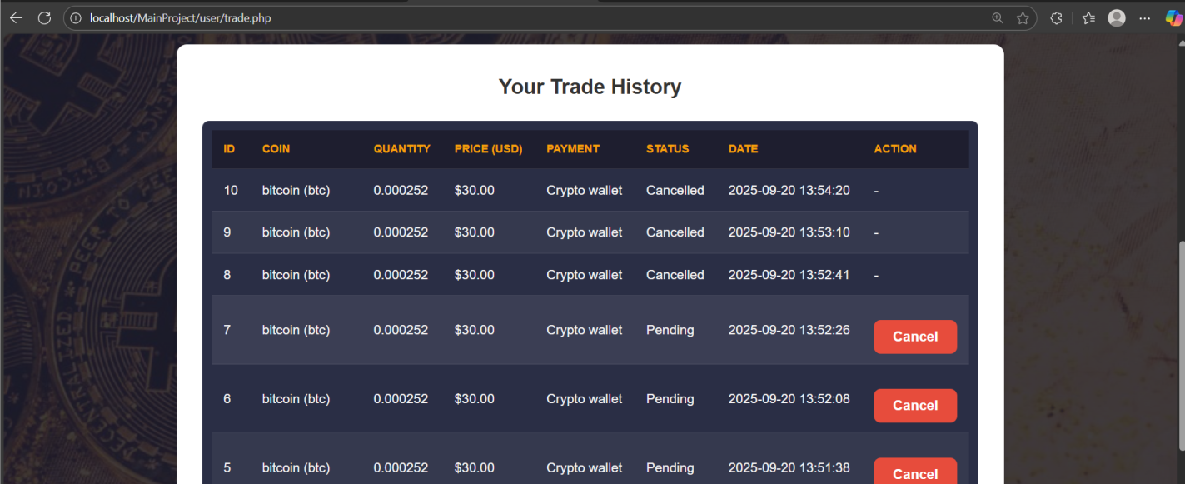  CONCLUSION:  This practical helped me understand how to use PHP with MySQL for database connectivity, perform queries, and display real-time user data on the web interface.

